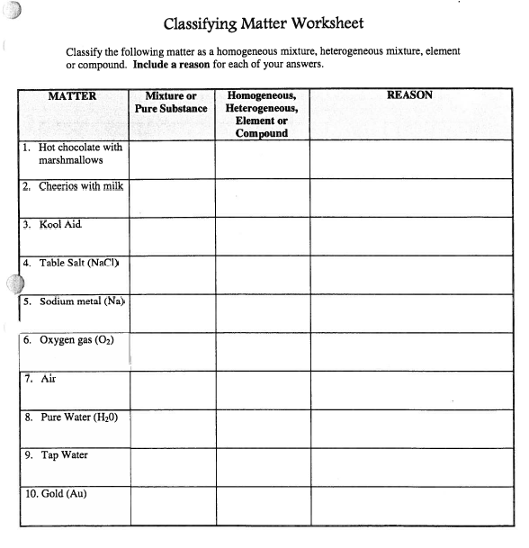

Only one type of atom

Only one type of atom

Only one type of atom

Combination of two types of atoms

Combination of two types of atoms

Every sip is the same

(GatorAid)

Every spoon has different number of cheerios

Every sip has different number of marshmallows

Homo

Homo

Homo

Hetero

Hetero

Compound

Compound

Element

Element

Element

Pure

Pure

Pure

Pure

Pure

Mixture

Mixture

Mixture

Mixture

Mixture